Circuit Analysis Lab 5
Submitted By:
Shumaim Jameel 2025-CE-116
Construction of Circuits and Tables
Proteus Circuits
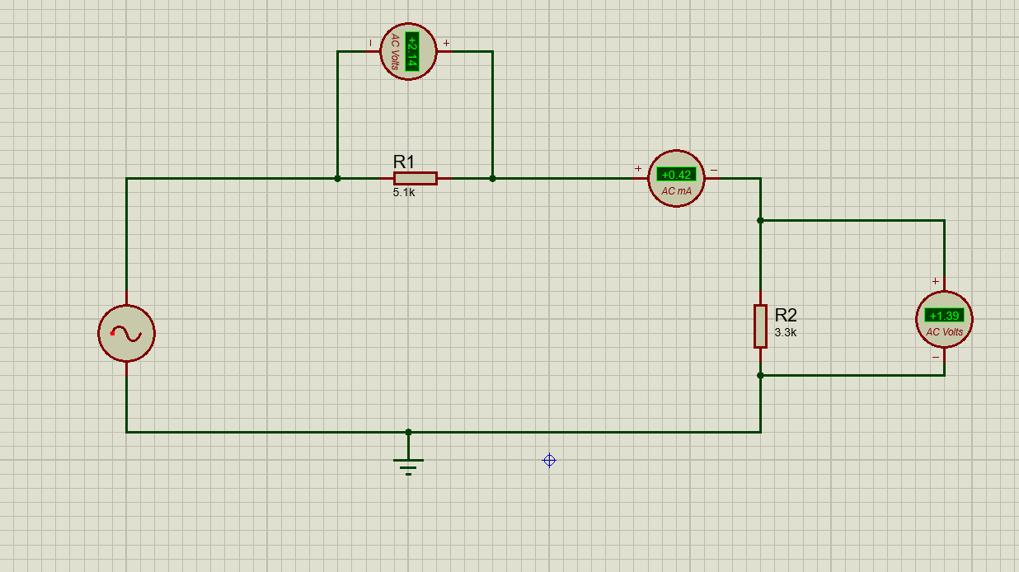
Proteus Circuit 1:

Explanation:
- Take an AC source (alternator) and connect its one terminal to resistor R1 (5.1 kΩ)
- From the other end of R1, connect a wire and place an ammeter in series
- From the ammeter, connect the wire to resistor R2 (3.3 kΩ)
- From the lower end of R2, connect the wire back to the other terminal of the AC source to complete the circuit
- Connect a voltmeter in parallel across R1 (one terminal before R1 and one after R1)
- Connect another voltmeter in parallel across R2 (one terminal at top of R2 and one at bottom of R2)
- Connect the bottom line of the circuit to ground as a reference point
- Ensure all connections are tight so current flows from source → R1 → ammeter → R2 → back to source
Simulated Values:
R1 Voltage | R2 Voltage | Current
2.14V | 1.39V | 0.42mA

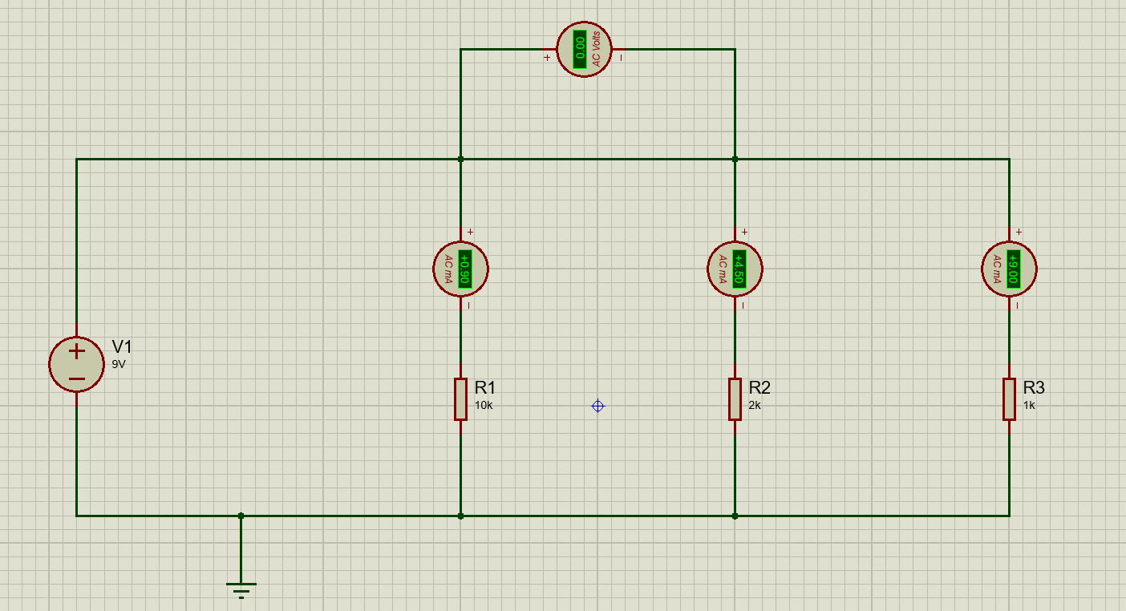
Proteus Circuit 1:

Explanation:
- Take a DC source (9V battery) and draw two main horizontal lines (top and bottom) to form parallel branches
- Connect the positive terminal of the battery to the top horizontal line and the negative terminal to the bottom line
- In the first vertical branch, connect an ammeter in series and then connect resistor R1 (10 kΩ) to the bottom line
- In the second vertical branch, connect another ammeter in series and then connect resistor R2 (2 kΩ) to the bottom line
- In the third vertical branch, connect another ammeter in series and then connect resistor R3 (1 kΩ) to the bottom line
- Connect a voltmeter in parallel across node 2 of resistor 1 and node 3 of resistor 2 to measure the supply voltage
- Join all lower ends of resistors to the bottom line to complete each branch
- Connect the bottom line to ground as a reference point
- Ensure all three resistors are connected in parallel between the same two nodes (top and bottom lines) so current divides in each branch.
Simulated Values:

R1 Current | R2 Current | R3 Current | Voltage
0.9mA | 4.5mA | 9mA | 9V

